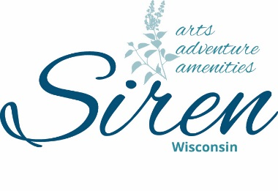
Siren Chamber of Commerce, Inc.
PO Box 57
Siren, WI 54872
715-349-8399
chamber@visitsiren.com

Siren Chamber of Commerce Board Meeting Agenda
August 8th , 2023, at 9:00 am
Future meeting days/times: Second Monday of the Month; 12:00PM, Village Hall

“The mission of the Siren Chamber of Commerce is to assist local businesses
and our community to grow and prosper.”

Attending Board Members: Chris Sybers, Sara Reimann, Dave Alden, Dr. Shelter, Wayne Koball(absent), Josie Woodman, Peggy Orman, Becky Popp, Jenni Smith

Call to Order: Chris called the meeting to order at 9:00am.
Approval of the Treasury Report: P&L Dave made a motion to Accept . Sara 2nd motion. M/C
Approval of Minutes from July 11th , 2023: Note date for Aug meeting wasn’t changed should of read Aug 7th.Dave made a motion to accept as read. Sara 2nd motion. M/C
Approval of Agenda – Peggy made a motion to accept as read. Sara 2nd motion. M/C
Old Business:
- Social Media Updates: Sara will give updates including website update including a website status update. Slow and steady. Will get pictures of events up.
- Street Dance: Band Booking Ideas. Dweeb? They charge $5,000 as of now. Dave made a motion to contact Dweebs for next year’s street dance. With this being will bring to tourism to help with cost Becky 2nd motion. M/C
- Destination Siren: Web & Jay have agreed to perform at the event. We are booked and ready to go. $800.00 cost to rent building.
- 4th of July: A thank you will be sent to Greg and Sue Hunter. Becky made a motion to accept. Sara 2nd motion. M/C
New Business:
- Golf Outing: Tavern League is asking the Siren Chamber to sponsor a golf hole for their tournament. We will sponsor a golf hole. Dave made a motion to this. Josie 2nd motion. M/C
- Newspaper ads: Does the Chamber want to advertise Harvestfest & destination Siren featuring Taste of Siren in the local newspapers and/ or pay for social media promotion? We will advertise on social media for $200.00 and will put small ad in newspaper. Small ad for vendors wanted. Dave made a motion. Becky 2nd motion. M/C
- Annual Dinner: Set a Date: Business of the year, Citizen of the year, & Volunteer of the year awards suggestions/decision. Pour House will be catering. The Chamber can pick a few menu ideas, or Sue Hunter can decide. Sara made a motion to have a taco bar with chicken, or beef. Dave 2nd motion. M/C.

- Next Board Meeting: October 10th at 9am, 2023, at 9am Village Hall.
Meeting Adjourn: Dave made a motion. Sara 2nd motion. M/C

Josie Penberthy, Submitted

